Chapter 4

**RESULTS AND DISCUSSION**

This chapter summarizes the study's findings and conclusions to the problems concerned with the development of the proposed Monitoring System for the municipality of Bolinao and provides recommendations on its proper implementation and further developments.

**Current Process in Tourism Office System**

The proponents conducted an interview with the Municipal Tourism Officer of Bolinao, Ms. Mary C. De Guzman, the <<add role here>>. The proponents were able to determine that the Tourism Office is using manual processes and Google Forms in recording tourism activities.

Registration of tourists’ data. Registration form is being distributed to a list of tourist sites and registered establishments by the Bolinao Tourism Office.

Tourist’s data is being collected by the Bolinao Tourism Office by requesting newly arrived guests to fill-up a registration form in tourist site and establishment. The guest will need to write down their information such as: name, nationality, age, date of birth, gender, address, contact information, date of arrival, and travel history. This process is required for every tourist site and establishment being visited by the guests.

Figure 8:

Registration of tourist’s data.

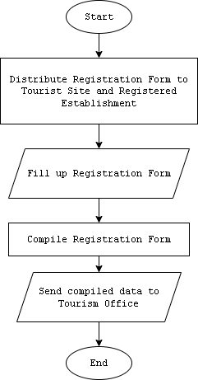

Collecting tourist data manually. Manual data collection of registration form is being done by the tourism office to tourist sites and establishments that has unavailable internet connection.

The collected data will then be compiled in the tourism office for encoding.

Figure 9:

Collecting tourist data manually.

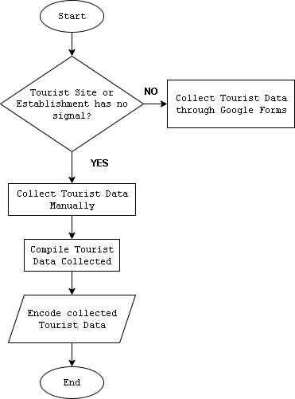

Tourist data collection through Google Forms. Tourist data collection through Google Forms is being made when the tourist site and establishment has access to the Internet.

The Google forms is made by the IT Staff of tourism office. Links will be distributed to the tourist sites and establishments that has access to the Internet. After accepting responses, all the data collected will be encoded by the tourism office for compilation.

Figure 10:

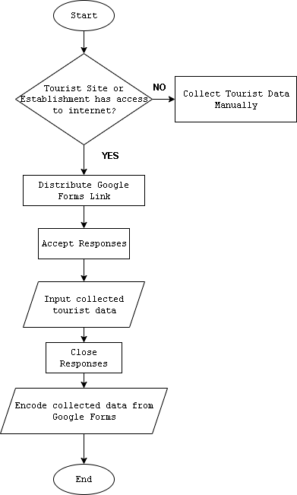Tourist data collection through Google Forms.

Encoding of data in Excel. Encoding is being by the tourism office manually through constant online work in the office. All data collected manually and through Google forms are then being compiled. The compiled data will then be encoded by the statistician of the tourism office through an Excel format provided by the Department of Tourism.

Figure 11:

Encoding of data in Excel.

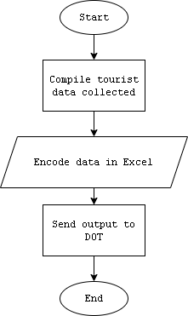

**Difficulties encountered in the current system of Tourism Office**

Based on the data gathered from the interview conducted with Ms. Mary C. De Guzman, the following are the difficulties encountered by the Tourism Office:

Limited network signals in other sites and establishments. Limited network signals to certain tourist sites and establishments results to manual collection of registration forms and manual generation of reports. This difficulty makes it hard for the tourism office to collect tourist data in a timely manner.

Harder to implement systems. The unavailability of internet connection to tourist site and establishment is limiting the tourism office in implementing a computer system for easy management of registration form and monitoring.

Time-consuming collection of data. The tourism office will need go to the tourist sites and establishments that has no network signals to collect tourist data. Certain areas take time to reach because there are some tourist sites and registered establishments that are in areas that requires sailing such as the tourist site in Santiago Island. Majority of tourist sites and registered establishments are also located in remote areas of Bolinao.

**Features of the Proposed Tourism Monitoring System**

The development of Tourism Monitoring System for Bolinao is designed to provide the following features:

Register Account. The system feature can only be accessed by making the user to register an account. OTP (One-time Password) will be required to successfully register.

By making the user register, they will be able to access the basic core features of the system.

Figure 12:

Register account.

User Profile Setting. This feature allows the user to see their Profile. This can be accessed upon successful login of the user and by navigating to the right part of the header.

Users will be able to edit their Profile Information and they are required to also add their gender and address to be able to request for booking.

Figure 13:

User Profile Setting.

Dashboard. This feature allows the user to see the current numbers of visits of a tourist site or establishments. The number of visits in the establishment will update in real-time whenever there is a new booking accepted by the staff accounts.

Figure 14:

Dashboard.

Live Map Counter. This feature allows users to see the map of Bolinao via map pins of the tourist sites and establishments. The counter will also update in real-time whenever a booking entry is approved. As for privacy concerns, the live map counter in the homepage will only show the pins of every tourist site and establishments. To see the live number of total visits in the map, the user needs to login or register an account.

Figure 15:

Live Map Counter.

Booking. This feature allows the user to be able to book in their chosen tourist site or establishment. This is a two-step process, where the first process will be the user info, this is to make sure that all information is correct before proceeding with the next page. User information can be modified by navigating to the Profile Setting page.

The second step will proceed on asking for additional information for the user. Users will be able to choose in a drop box the list of registered tourist site or establishment in the system. Upon choosing the location, the user will be given a ticket code that will be to the staff assigned to that tourist site or establishment. The staff will need to approve the request upon confirming the ticket code of the user. The following figure shows the steps in booking:

Figure 16:

Booking – User Info.

Figure 17:

Booking – Additional Information.

Figure 18:

Booking – Generate Ticket Number.

Pending Request Logs. This feature allows the user to see the list of active booking requested. Users can also cancel the booking request.

Figure 19:

Request Logs.

Add Site Location. This will allow the tourism office to add specific locations of tourist sites and registered establishments according to its name, latitude, and longitude.

Figure 20:

Adding Site Location in Live Map.

Staff Account Creation. This feature allows the tourism office to create designated staff accounts for specific tourist sites and registered establishments.

Staff accounts have different functionalities that will help in managing and monitoring the designated site or establishment of that account. Staff accounts can only be created if the designated site or establishment has no existing staff account.

Figure 21:

Staff Account Creation.

Notification. Staff accounts will be able to create notifications for users to see updates related to the site or establishments. The notifications can be seen by the users when created including which staff account created the notification. The figures below show the following functionalities of the feature:

Figure 22:

Create Notification.

Figure 23:

Create Notification Modal.

Figure 24:

Notification Page – User.

**Acceptability test of Tourism Monitoring System**

In the completion of the proposed system Tourism Monitoring System for Bolinao, the system will be accessed by the Tourism Office and the IT faculty of PSU – ACC.

Functionality. <Table Number> shows the perception of evaluators on the system with respect to its functionality. The respondent rate functionality of the system is reflected with an overall mean of <Placeholder> which interprets as <Placeholder>. The functions of the system are appropriate in terms of suitability, with a total average weighted mean of <Placeholder>, which translates to <Placeholder>. The measured data can be used by the registrar for data appropriateness. In terms of accuracy, <Name of System> has a total average weighted mean of <Placeholder>, which translates to <Placeholder>, the <Name of System> adheres to existing standards and policies. For security, the system prevents unauthorized access with an average weighted mean of <Placeholder>, which is considered <Placeholder>. The developed system can provide security to authorized personnel such as usernames and passwords in accessing the system.

Table 5:

System Evaluation According to Functionality.

|  |  |  |
| --- | --- | --- |
| **FUNCTIONALITY** | **Mean** | **Description** |
| 1. Suitability – The functions of the system are appropriate. | <Placeholder> | <Placeholder> |
| 2. Accuracy – The system’s results are accurate. | <Placeholder> | <Placeholder> |
| 3. Security – It prevents unauthorized access. | <Placeholder> | <Placeholder> |
| Weighted Mean | <Placeholder> | <Placeholder> |

Reliability. Table <Placeholder> shows clients' perceptions as evaluators of the application's reliability. According to maturity, which states the minimal frequency of software faults and failures, the application garnered <Placeholder> percent. This means that errors in the application are at the very least. The application garnered a mean of <Placeholder> percent in terms of fault tolerance. This states that the application is capable of handling errors. For recoverability, the application garnered a mean of <Placeholder>, which says that it can easily recover its performance in case of error. The overall weighted mean of the application is <Placeholder>, marked as <Placeholder>.

Table 6:

System Evaluation According to Reliability.

|  |  |  |
| --- | --- | --- |
| **RELIABILITY** | **Mean** | **Description** |
| 1. Maturity – There is a minimum frequency of software faults/failures. | <Placeholder> | <Placeholder> |
| 2. Fault Tolerance – The system can handle system errors. | <Placeholder> | <Placeholder> |
| 3. Recoverability – System’s performance is re-establishing from failure. | <Placeholder> | <Placeholder> |
| Weighted Mean | <Placeholder> | <Placeholder> |

Usability. Table <Num> shows clients' perceptions as evaluators of the application's usability. According to understandability, which states that the concepts incorporated in the application are easy to recognize, the application garnered a <Placeholder> percent. This means that the words, icons, and buttons added to the application are easy to understand. In terms of learnability, the application garnered a mean of <Placeholder> percent. This states that the processes occurring in the application are easy to understand. For operability, the application garnered a mean of <Placeholder> which states that the controls and different interfaces are easy to navigate. The overall weighted mean of the application is <Placeholder>, marked as <Placeholder>.

Table 7:

System Evaluation According to Usability.

|  |  |  |
| --- | --- | --- |
| **USABILITY** | **Mean** | **Description** |
| 1. Understandability – Concepts are easily recognized. | <Placeholder> | <Placeholder> |
| 2. Learnability – The system’s functions are easy to learn | <Placeholder> | <Placeholder> |
| 3. Operability – The system is easy to use or operate. | <Placeholder> | <Placeholder> |
| **Weighted Mean** | <Placeholder> | <Placeholder> |

Efficiency. Table <Num> shows clients' perceptions as evaluators of the application's efficiency. According to its time behavior, which states a fast response time, the application garnered a mean of <Placeholder> percent. This means a relatively fast response time in the application's performance. The application garnered a mean of <Placeholder>­ percent in terms of resource behavior. This states that the data inputs for the application are easy to provide. The overall weighted mean of the application is <Placeholder>, marked as <Placeholder>.

Table 8:

System Evaluation According to Efficiency.

|  |  |  |
| --- | --- | --- |
| **EFFICIENCY** | **Mean** | **Description** |
| 1. Time Behavior – There is a fast response time in the system. | <Placeholder> | <Placeholder> |
| 2. Resource Behavior – Resources used for system performance are accessible. | <Placeholder> | <Placeholder> |
| **Weighted Mean** | <Placeholder> | <Placeholder> |

Maintainability. Table <num> shows clients' perceptions as evaluators of the application's maintainability. According to its analyzability, which states that failures can be easily identified, the application garnered 4.56 percent. This means that the application does an excellent job of informing the user about the errors in the processes done in the application. In terms of stability, the application garnered a mean of 4.78 percent. This states that the components inside the application are easy to modify. The overall weighted mean of the application is 4.67, marked as excellent.

Table 8:

System Evaluation According to Maintainability.

|  |  |  |
| --- | --- | --- |
| **MAINTANABILITY** | **Mean** | **Description** |
| 1. Analyzability – There is less effort in identifying system failure causes. | <Placeholder> | <Placeholder> |
| 1. Changeability – Effort in modifying the system | <Placeholder> | <Placeholder> |
| 1. Stability – Sensitivity to modification | <Placeholder> | <Placeholder> |
| **Weighted Mean** | <Placeholder> | <Placeholder> |

Portability. Table <num> in shows the perception of evaluators on the application with respect to portability. The respondents rate portability of the system as reflected with an overall mean of <Placeholder> which interprets as <Placeholder>. In adaptability, specification changes in the system are done easily with an average weighted mean of <Placeholder> which interprets as <Placeholder>. In install ability, there is effortless process of installing the application in mobile phone with an average weighted mean of <Placeholder> which interprets as <Placeholder>. In conformance, the mobile application and device is compliant to portability standards with an average weighted mean of <Placeholder> which interprets as <Placeholder>.

Table 9:

System Evaluation According to Portability.

|  |  |  |
| --- | --- | --- |
| **PORTABILITY** | **Mean** | **Description** |
| 1. Analyzability – There is less effort in identifying system failure causes. | <Placeholder> | <Placeholder> |
| 1. Changeability – Effort in modifying the system | <Placeholder> | <Placeholder> |
| 1. Stability – Sensitivity to modification | <Placeholder> | <Placeholder> |
| **Weighted Mean** | <Placeholder> | <Placeholder> |

Table <num> and Table <num> shows the overall weighted mean of the acceptability test of the Tourism Monitoring System.

Table 10:

Overall Weighted Mean for Tourism Officers.

|  |  |  |
| --- | --- | --- |
| **AREA** | **Average Weighted Mean** | **Description** |
| 1. Functionality | <Placeholder> | <Placeholder> |
| 1. Reliability | <Placeholder> | <Placeholder> |
| 1. Usability | <Placeholder> | <Placeholder> |
| 1. Efficiency | <Placeholder> | <Placeholder> |
| 1. Maintainability | <Placeholder> | <Placeholder> |
| 1. Portability | <Placeholder> | <Placeholder> |
| **Overall Weighted Mean** | <Placeholder> | <Placeholder> |

Table 11:

Overall Weighted Mean for PSU – ACC IT Staff.

|  |  |  |
| --- | --- | --- |
| **AREA** | **Average Weighted Mean** | **Description** |
| 1. Functionality | <Placeholder> | <Placeholder> |
| 1. Reliability | <Placeholder> | <Placeholder> |
| 1. Usability | <Placeholder> | <Placeholder> |
| 1. Efficiency | <Placeholder> | <Placeholder> |
| 1. Maintainability | <Placeholder> | <Placeholder> |
| 1. Portability | <Placeholder> | <Placeholder> |
| **Overall Weighted Mean** | <Placeholder> | <Placeholder> |

With the computed OWM for tourism office acceptability test of <placeholder> and IT staff acceptability test of <placeholder> both interpreted as <placeholder>, the application is ready for deployment.